**Graph Data Stucture**

A graph data structure is a **collection of nodes that have data** and **are connected to other nodes**.

Let's try to understand this through an example. On facebook, **everything is a node**. That includes User, Photo, Album, Event, Group, Page, Comment, Story, Video, Link, Note...anything that has data is a node.

Every **relationship is an edge** from one node to another. Whether you post a photo, join a group, like a page, etc., a **new edge is created for that relationship.**

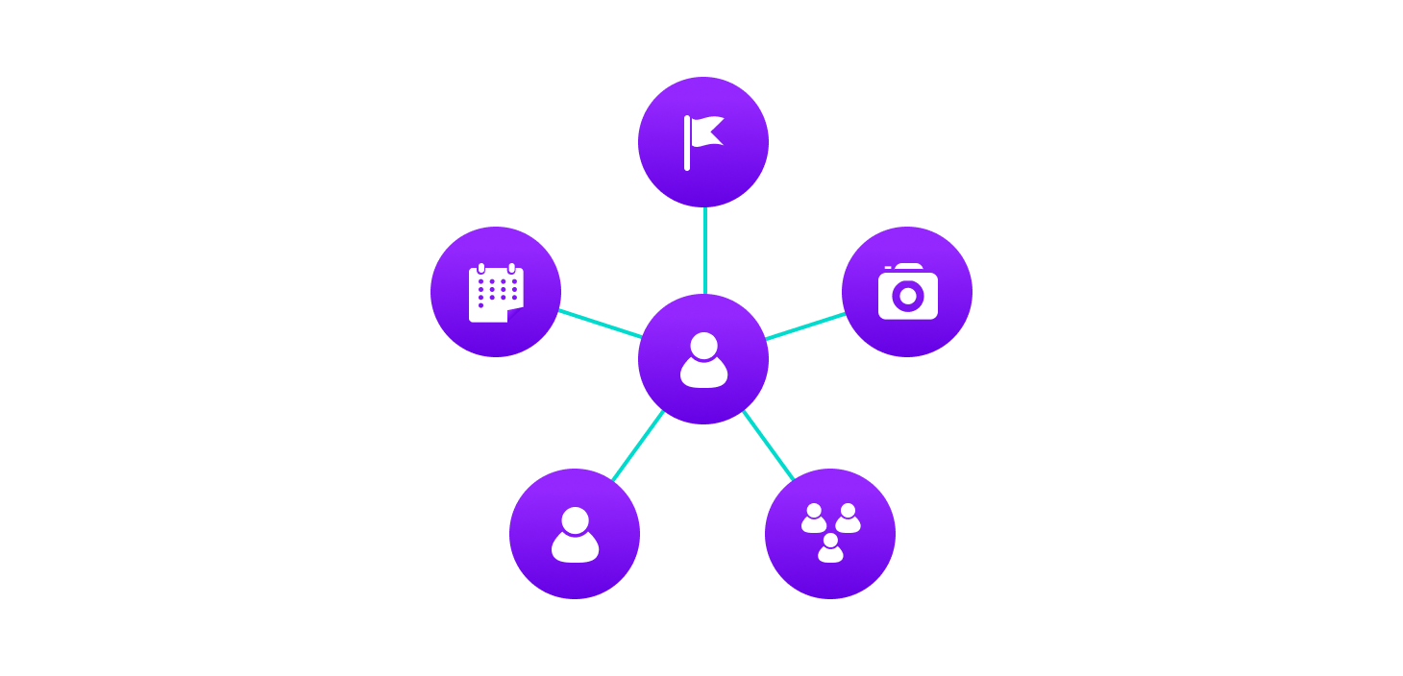**Example Of Graph Data Structure**

All of facebook is then a **collection** of **these nodes and edges**. This is because facebook uses a graph data structure to store its data.

More precisely, a graph is a data structure (V, E) that consists of

* A collection of **vertices** **V**
* A collection of **edges E**

**Vertices and edges**

**Graph Terminology**

* **Adjacency**: A **vertex is said to be adjacent** to **another vertex if there is an edge** connecting them.
* **Path**: A **sequence of edges** that **allows** **you** to **go from vertex A to vertex B is called a path**. 0-1, 1-2 and 0-2 are paths from vertex 0 to vertex 2.
* **Directed Graph**: A **directed graph** is defined as a type of **graph** where the **edges have a direction associated with them**.

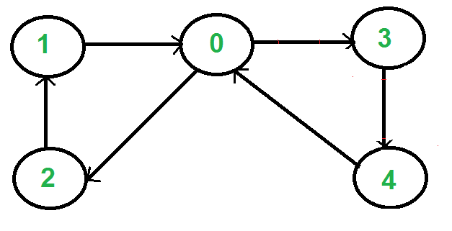

**Null Graph**

A graph is known as a null graph if there are no edges in the graph.

**Trivial Graph**

Graph having only a single vertex, it is also the smallest graph possible.

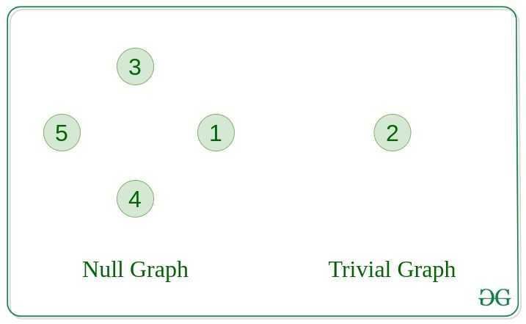

**Undirected Graph**

A graph in which edges do not have any direction.

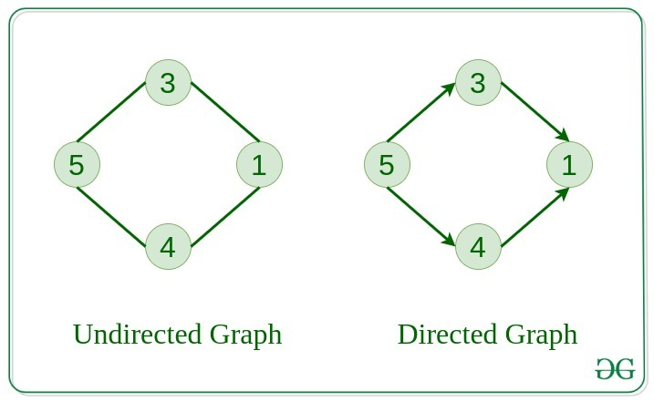

**Connected Graph**

The graph in which from one node we can visit any other node in the graph is known as a connected graph.

**Disconnected Graph**

The graph in which at least one node is not reachable from a node is known as a disconnected graph.

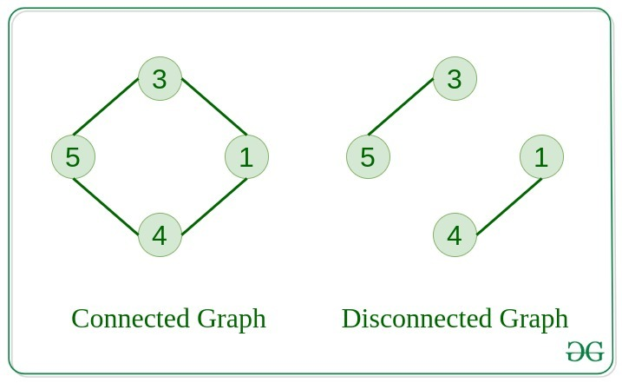

**Complete Graph**

The graph in which from each node there is an edge to each other node.

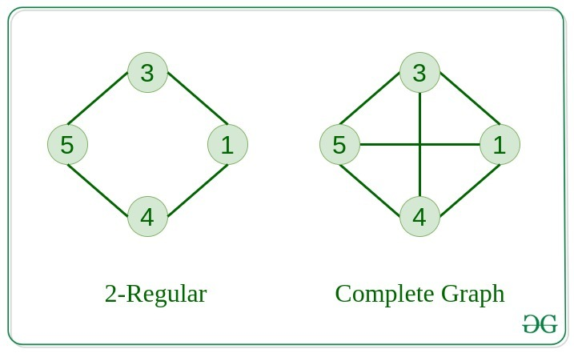

**Regular Graph**

The graph in which the **degree of every vertex** is **equal to K** is called K regular graph.

**Cyclic Graph**

A graph containing at least one cycle is known as a Cyclic graph

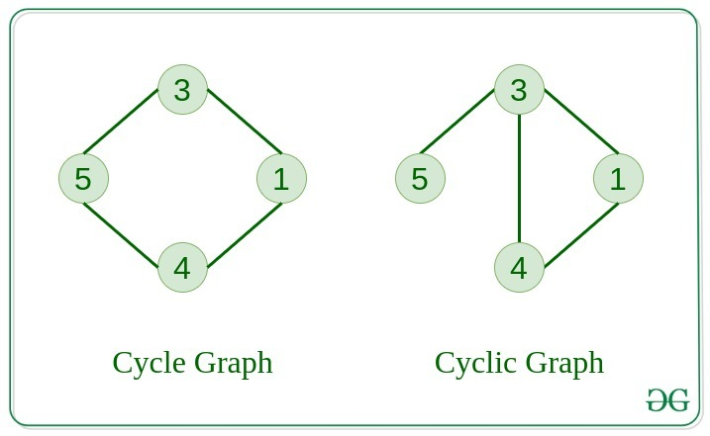

**Graph Representation**

Graphs are commonly represented in two ways:

**1. Adjacency Matrix**

An adjacency matrix is a **2D array of V x V vertices**. Each row and column represent a **vertex**.

If the value of any element **a[i][j] is 1**, it **represents** that **there is an edge** connecting **vertex i and vertex j.**

The adjacency matrix for the graph we created above is

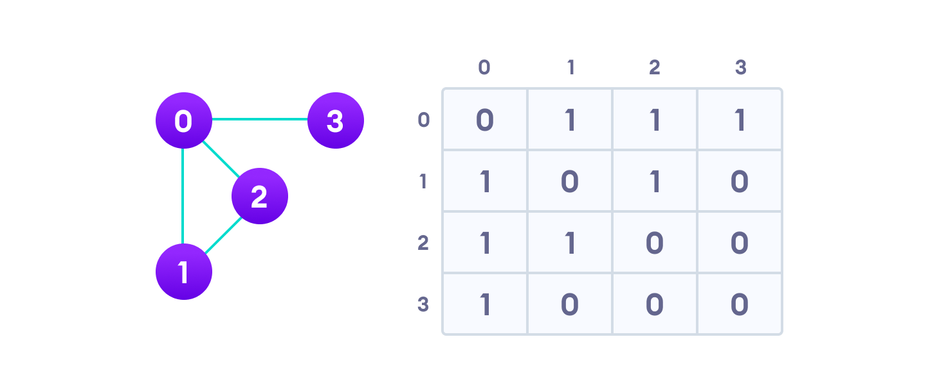**Graph Adjacency Matrix**

**2. Adjacency List**

An adjacency list represents a graph **as an array of linked lists.**

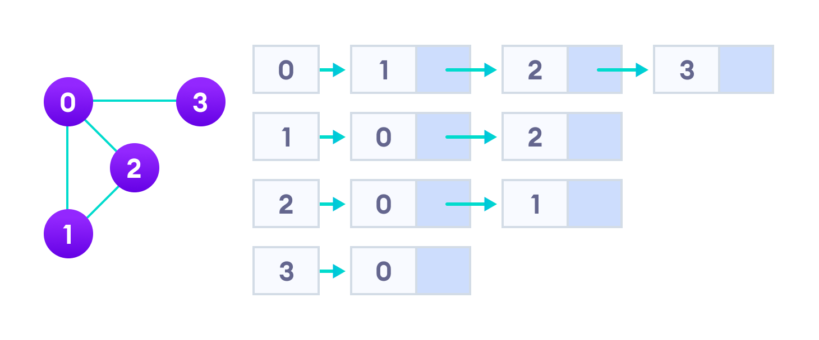

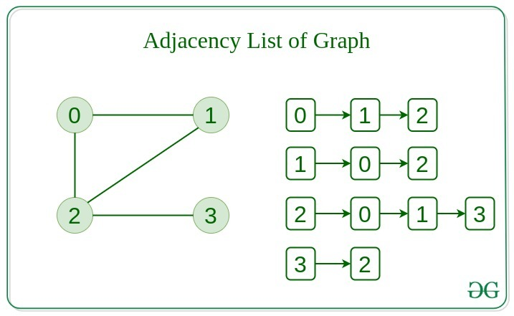

**Adjacency List Representation**

An adjacency list is **efficient** in terms of **storage because we only need to store the values** for the **edges**. For a graph with millions of vertices, this can mean a lot of saved space.

**Graph Operations**

The most common graph operations are:

* **Check if the element is present in the graph**
* **Graph Traversal**
* **Add elements (vertex, edges) to graph**
* **Finding the path from one vertex to another**

**Difference Between Tree And Graph:**

**Tree** is a **restricted** type of **Graph** Data Structure, just with some more rules**. Every tree will always be a graph** but not all graphs will be trees.

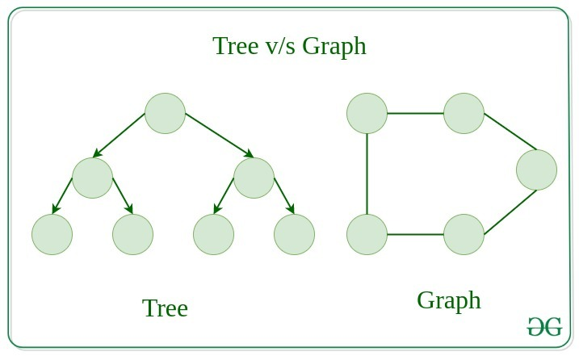

# Breadth First Search or BFS for a Graph

The **Breadth First Search (BFS)** algorithm is used to **search a graph data structure** for a **node** that **meets a set of criteria.**

**It** **starts at the root of the graph and visits all nodes at the current depth level before moving on to the nodes at the next depth level**.

**Relation between BFS for Graph and Tree traversal:**

[Breadth-First Traversal (or Search)](http://en.wikipedia.org/wiki/Breadth-first_search) for a graph is similar to the [Breadth-First Traversal of a tree](https://www.geeksforgeeks.org/level-order-tree-traversal/).

The only catch here is, that, unlike trees, graphs may contain cycles, **so we may come to the same node again.** To avoid processing a node more than once, we divide the vertices into two categories:

* **Visited and**
* **Not visited.**

A boolean visited array is **used to mark the visited vertices.** For simplicity, it is assumed that all vertices are reachable from the starting vertex. BFS uses a [**queue data structure**](https://www.geeksforgeeks.org/queue-data-structure/) for traversal.

**How does BFS work?**

**Starting** **from the root**, **all the nodes at a particular level are visited first** and then the nodes of the next level are traversed till all the nodes are visited.

To do this **a queue is used.** All the **adjacent unvisited nodes** of the current level are pushed into the queue and the **nodes of the current level are marked visited** and popped from the queue.

**Illustration:**

Let us understand the working of the algorithm with the help of the following example.

**Step1:**Initially queue and visited arrays are empty.

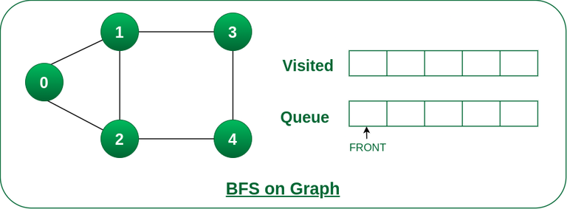

**Queue and visited arrays are empty initially.**

**Step2:**Push node 0 into queue and mark it visited.

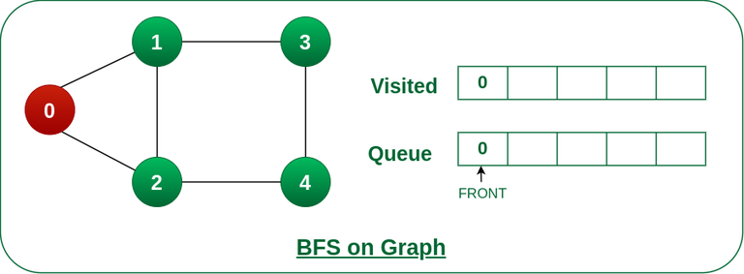

**Push node 0 into queue and mark it visited.**

***Step 3:***Remove node 0 from the front of queue and visit the unvisited neighbours and push them into queue.

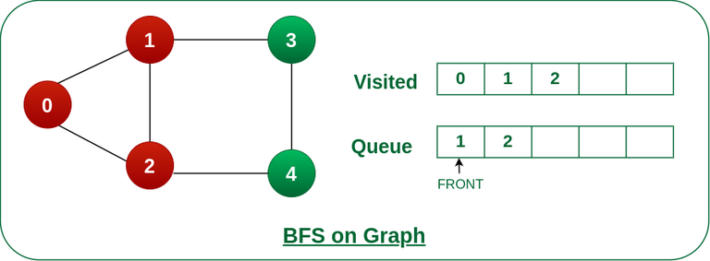

**Remove node 0 from the front of queue and visited the unvisited neighbours and push into queue.**

**Step 4:** **Remove** **node 1 from the front of queue** and **visit the unvisited neighbours and push them into queue.**

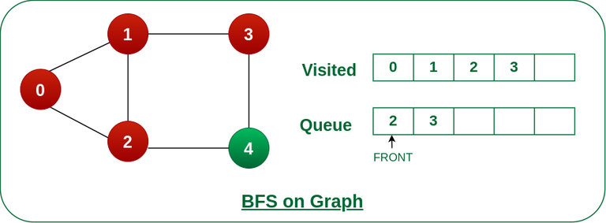

**Remove node 1 from the front of queue and visited the unvisited neighbours and push**

**Step 5:** **Remove node 2 from the front of queue and visit the unvisited neighbours** and **push** them into queue.

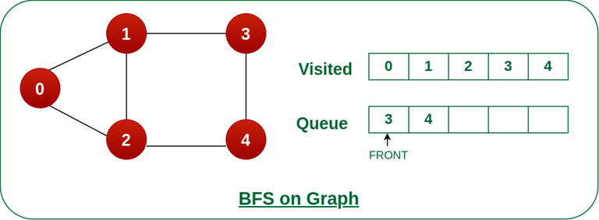

**Remove node 2 from the front of queue and visit the unvisited neighbours and push them into queue.**

**Step 6: Remove node 3 from the front of queue** and **visit the unvisited neighbours** and **push them into queue.** As we can see that **every neighbours of node 3 is visited**, so move to the next node that are in the front of the queue.

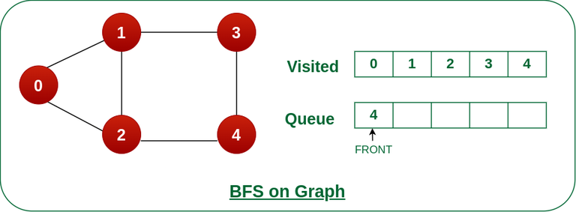

**Remove node 3 from the front of queue and visit the unvisited neighbours and push them into queue.**

**Steps 7: Remove node 4 from the front** of queue and **visit the unvisited neighbours** and **push them into queue.**As we can see that every **neighbours of node 4 are visited,** so move to the next node that is in the front of the queue.

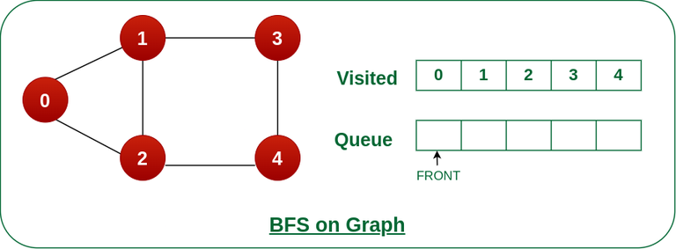

**Remove node 4 from the front of queue and visit the unvisited neighbours and push them into queue.**

Now, Queue becomes empty, **So, terminate these process of iteration.**

# Depth First Search or DFS for a Graph

**Depth First Traversal (or DFS)** for a graph is similar to [Depth First Traversal of a tree.](https://www.geeksforgeeks.org/tree-traversals-inorder-preorder-and-postorder/) The only catch here is, that, unlike trees, graphs may contain cycles (a node may be visited twice). **To avoid processing a node more than once, use a boolean visited array.** A graph can have more than one DFS traversal.





**How does DFS work?**

Depth-first search is an algorithm for traversing or searching tree or graph data structures. The **algorithm starts at the root node** and **explores as far as possible** along each branch before backtracking.

Let us understand the working of **Depth First Search** with the help of the following illustration:

**Step1:** Initially stack and visited arrays are empty.

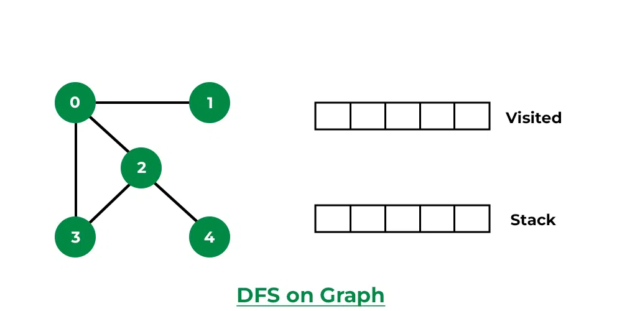

**Stack and visited arrays are empty initially.**

**Step 2:** **Visit 0 and put its adjacent nodes which are not visited yet into the stack**.

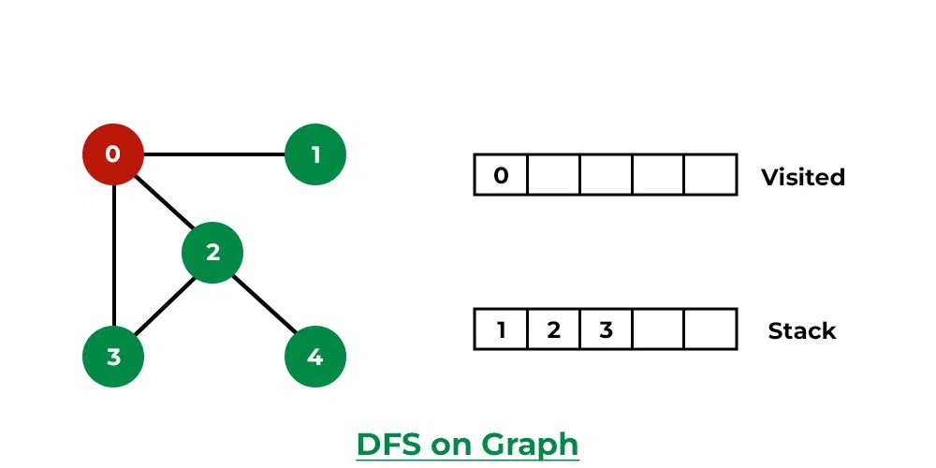

**Visit node 0 and put its adjacent nodes (1, 2, 3) into the stack**

**Step 3:** Now, **Node 1 at the top of the stack**, so **visit node 1 and pop it from the stack** and **put all of its adjacent nodes which are not visited** in the stack.

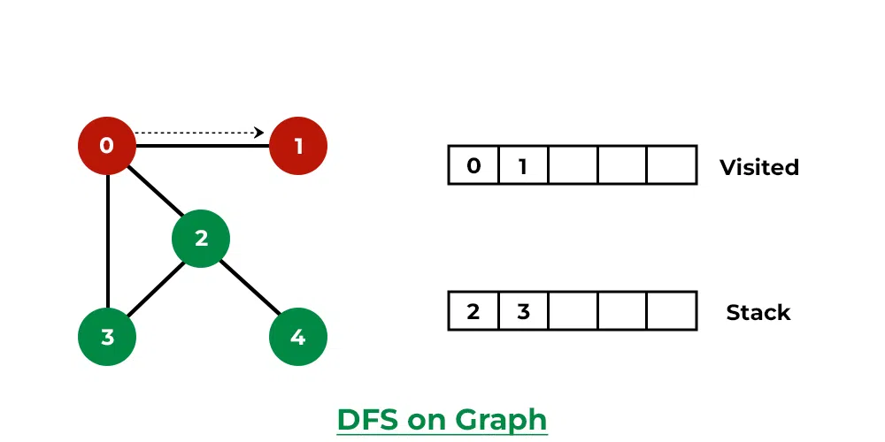

**Visit node 1**

**Step 4:**Now,**Node 2 at the top of the stack**, so visit node 2 and pop it from the stack and p**ut all of its adjacent nodes which are not visited (i.e, 3, 4) in the stack.**

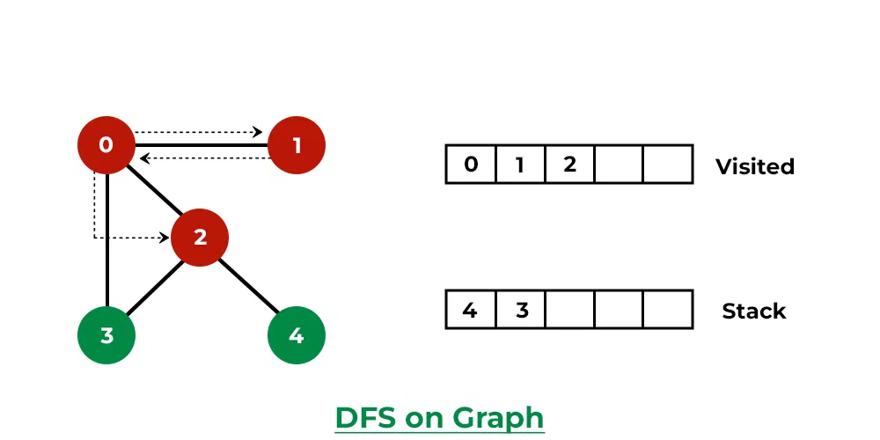

**Visit node 2 and put its unvisited adjacent nodes (3, 4) into the stack**

**Step 5:** Now, **Node 4 at the top of the stack**, so visit node 4 and pop it from the stack and put all of its adjacent nodes which are not visited in the stack.

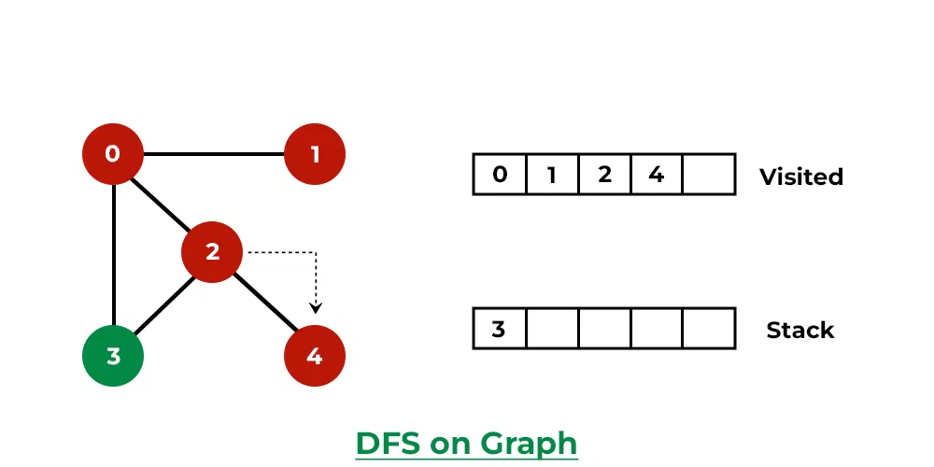

**Visit node 4**

**Step 6:** Now, **Node 3 at the top of the stack**, so visit node 3 and **pop it from the stack** and put all of its adjacent nodes which are not visited in the stack.

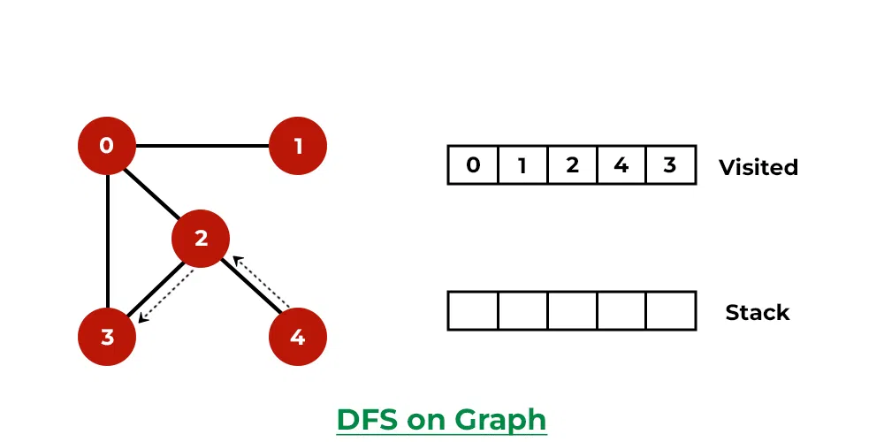

**Visit node 3**

Now, **Stack becomes empty,** which means **we have visited all the nodes** and our DFS traversal ends.